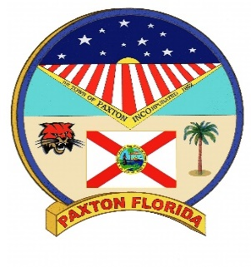
City of Paxton
2nd ANNUAL BOBBY KEMP DAY FESTIVAL
SEPTEMBER 09, 2023
SPONSOR REGISTRATION FORM

COMPANY NAME: __________________________________________________________________________________
CONTACT: ___________________________________________________________________________________________
ADDRESS: ___________________________________________________________________________________________
TELEPHONE #: _____________________________________________________________________________________
EMAIL ADDRESS: __________________________________________________________________________________
LEVEL √ | TYPE | SPACE | PRICE
 | PAPA |  | $500
 | BOBBY |  | $250
 | UNCLE JESSIE |  | $100
 | CONTRIBUTING DONOR |  | $

CITY OF PAXTON SPONSORSHIP BENEFITS Due By: August 12, 2023
PAPA PACKAGE
Sponsor logo and name featured on City’s website events page.
Inclusion in all promotional mentions at event and verbal recognition during event.
Prominent category identification at event.
FREE 10 X 12 Booth space area to showcase products/services at event.
Sponsor acknowledgement at opening ceremonies and at City Council Meeting.
Custom Yard Sign

BOBBY PACKAGE
Inclusion in all promotional mentions at event and verbal recognition during event.
Prominent category identification at event.
FREE 10 X 12 Booth space area to showcase products/services at event.
Sponsor acknowledgement at opening ceremonies and at City Council Meeting.

UNCLE JESSIE PACKAGE
Prominent category identification at event.
FREE 10 X 12 Booth space area to showcase products/services at event.
Sponsor acknowledgement at opening ceremonies and at City Council Meeting.

CONTRIBUTING SPONSORSHIP
Sponsor acknowledgement at opening ceremonies and at City Council Meeting.

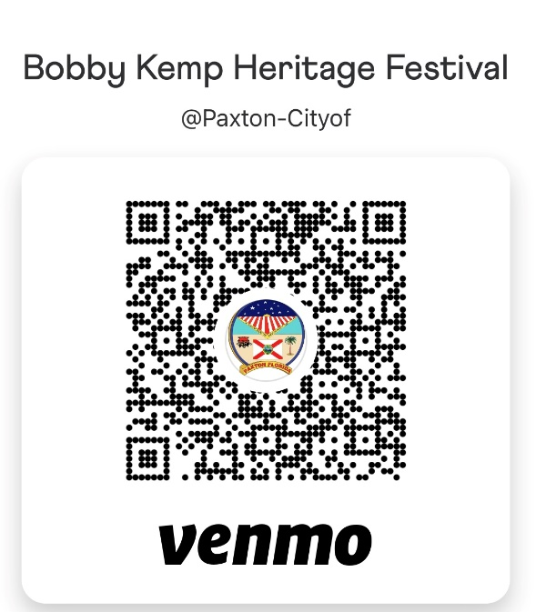

Please make checks out to the City of Paxton with BK Festival in the memo

