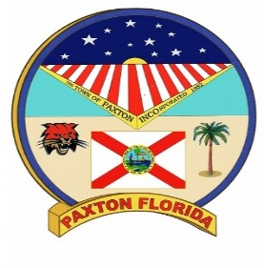
City of Paxton
Bobby Kemp Heritage Festival Committee Meeting
AGENDA
March 12, 2024 @ 6:00 p.m.
Sheriff’s Substation

- Meeting Called to Order
- Recognition of Guests
- Consent Agenda
  - Meeting Minutes – (February 8, 2024)
- Approval of Consent Agenda
- Consideration of Additions/Deletions to Agenda
- Approval of Agenda with Additions/Deletions
- Old Business (note: this is for items previously discussed by the Council)
  - Update on Scholarship Applications
  - Scoring Sheet for the Scholarship Application
  - Update – Shane Owens Entertainment
- New Business
  - Design for this year’s t-shirts
  - Beauty Pageant
  - New Signage for the Sponsorship
- Adjournment

The City of Paxton may take action on any matter during this meeting, including items that are not set forth within this agenda.
In accordance with Section 286.26, Florida Statutes, persons with disabilities needing special accommodations to participate in this meeting should contact the City Clerk’s office at (850)-834-2489 by 5:00 p.m. on the day prior to the meeting.
No verbatim record by a certified court reporter is made of these proceedings. Accordingly, any person who may seek to appeal any decision involving the matters noticed herein will be responsible for making a verbatim record of the testimony and evidence at these proceedings upon which any appeal is to be based (see Section 286.0105, Florida Statutes).

